RGB And Dimmable Lighting Demo

# Hardware Environment

1. MIMXRT1050-EVKB
2. DR1175 1V2 Light Module
3. Cypress WiFi Module – J1’s pin 2 and 3 should be short connected with a jumper, leave other pins opened.

# Software Environment

1. SDK – [linkit_demo](https://github.com/junexunxp/linkit_demo_cypress).
2. IDE – IAR Embedded Workbench for ARM – v8.32.4.
3. Android App for ALI platform:

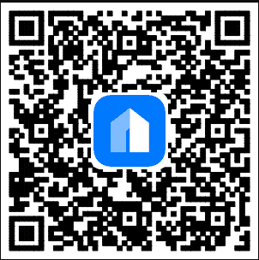

# SDK Porting Settings

This step already done, there is no need to do the porting work unless you want to do the porting work again.

* SDK Settings
  + Turn off the data co-processor (DCP) feature by change settings of MIMXRT1052_features.h:

#define FSL_FEATURE_SOC_DCP_COUNT (0)

* + MBEDTLS_CONFIG_FILE="ksdk_mbedtls_config.h"
  + PRINTF_ADVANCED_ENABLE=1
  + PRINTF_FLOAT_ENABLE=1
* CSDK Extract Settings

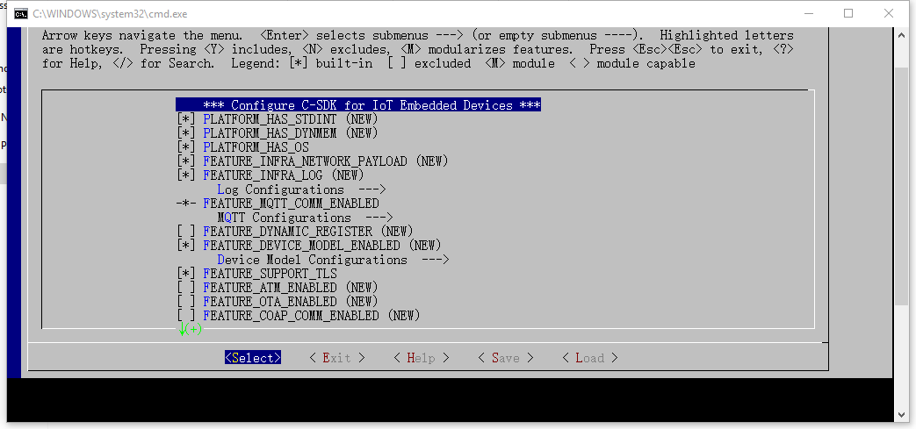

* + PLATFORM_HAS_STDINT
  + PLATFORM_HAS_DYNMEM
  + PLATFORM_HAS_OS enabled to use Free-RTOS
  + FEATURE_INFRA_NETWORK_PAYLOAD
  + FEATURE_INFRA_LOG
  + FEATURE_MQTT_COMM_ENABLED
    - FEATURE_MQTT_DEFAULT_IMPL
    - FEATURE_MQTT_DIRECT
  + DEVICE_MODEL_ENABLED
    - DEVICE_MODEL_SHADOW
  + SUPPORT_TLS enabled to use mbedtls to secure the communication
  + DEV_BIND_ENABLED enabled to let app bind with device through CoAP messages.

Setup Step

1. Download the linkit demo SDK from below link:

<https://github.com/junexunxp/linkit_demo_cypress>

1. Open file ../ linkit_demo_cypress/linkit_demo.eww, the SDK file structures listed as below:

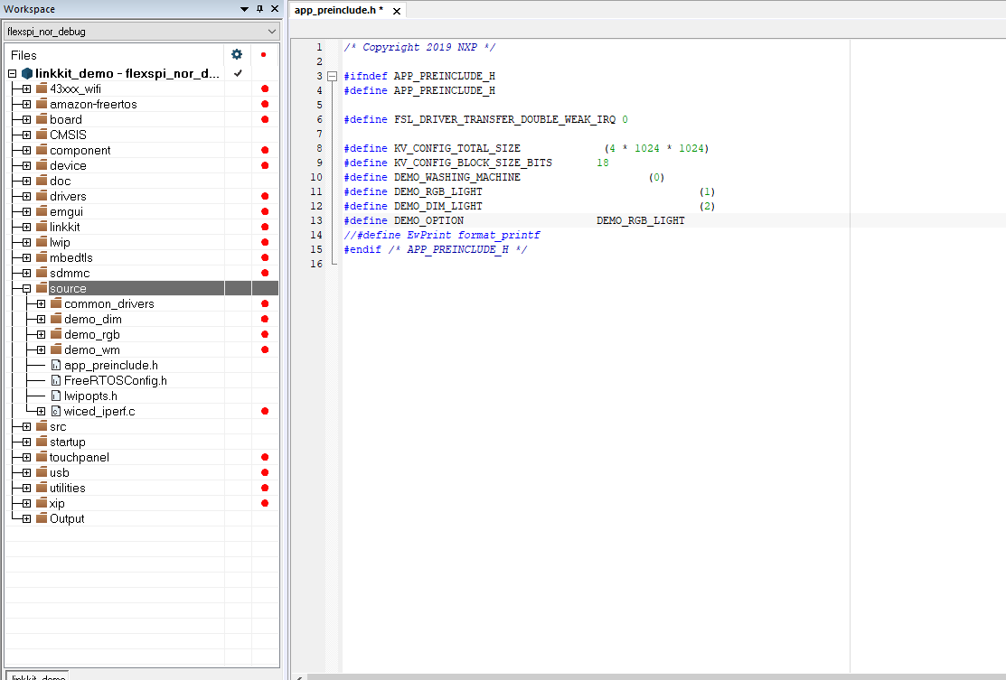

1. Open file source/app_preinclude.h, change the macro definition DEMO_OPTION to DEMO_DIM_LIGHT to run the dimmable light demo, or change DEMO_OPTION to DEMO_RGB_LIGHT to run the RGB light demo.
2. From IAR’s left top corner select compile option “flexspi_nor_debug”, then make the project.
3. Light module DR1175 connected to IMXRT1050 EVKB by using the Arduino interface as below:

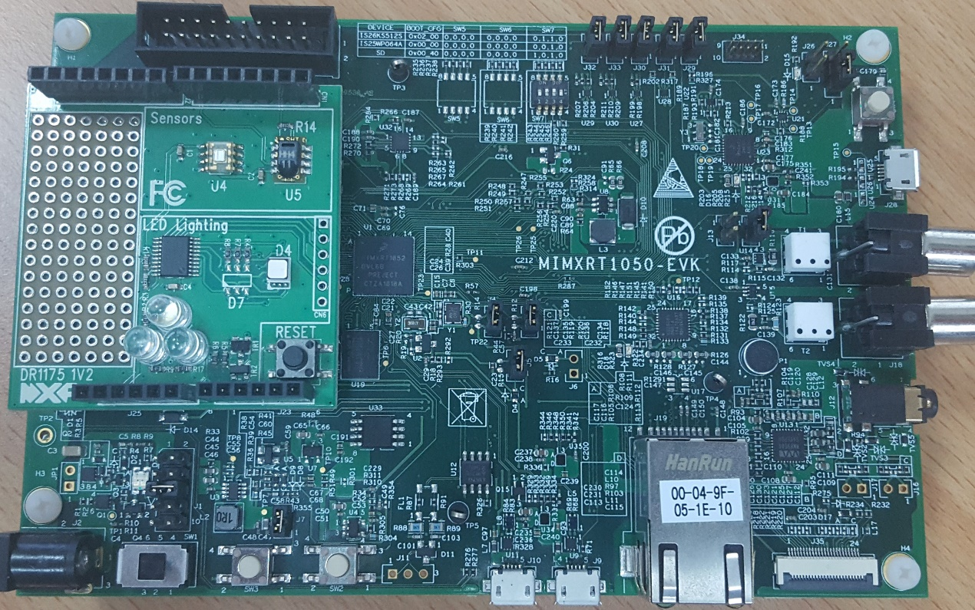

1. Download compiled image to the EVKB and reset the board.
2. Connect IMXRT1050 EVKB’s J9 micro USB port to PC, and open a serial port communication tool, e.g.“putty”, use the shell command to configure the WiFi security materials to 1050 EVKB, the command use: **“iwconfig wlan0 ssid iPhone key 12345678”.**

It will connect to AP “iPhone” with key “12345678”.

1. Connect your Android phone to the same AP as step 7, open Ali Cloud App, press the “+” button on the right top corner, now you can see the device and add it.

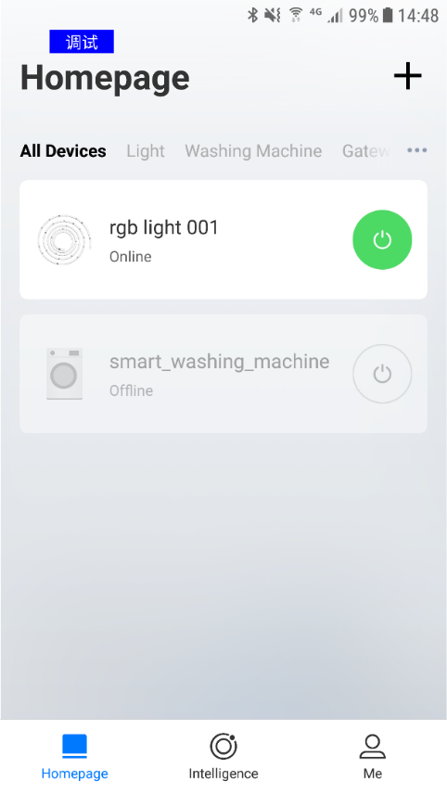 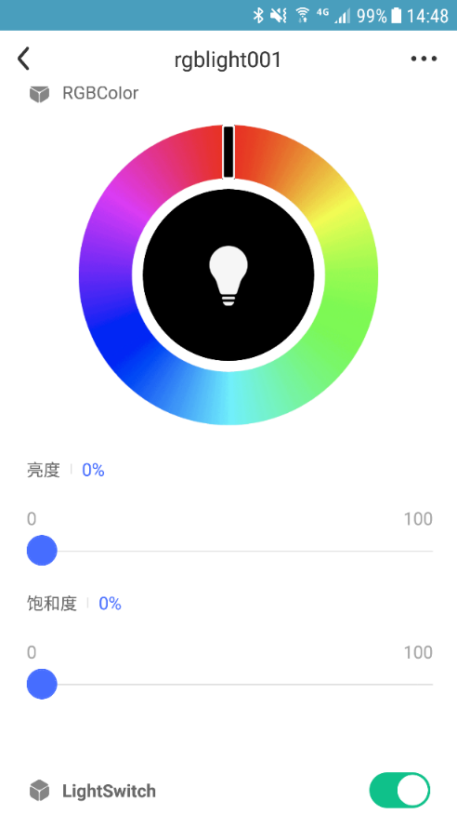

1. The demo results as below.

